**Aim:** Design a Web Application for an Organization with Registration forms and advanced controls also Create website using master page concept.

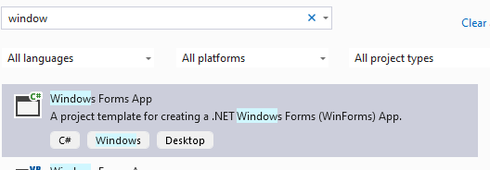

Next, Next then create

INSIDE THIS WE USE MYSQL CONNECTOR AND IT WILL DISPLAY IT ON LOCALHOST

THIS APPROCH WILL GIVE THIS



2.1 Design Registration Form for volunteers in an NGO having following properties/attributes: v_id, v_name, v_emailid, v_phone, v_address, v_skills, v_availability Display the attributes entered by the user on a different page

### Code:

Detail.aspx- using System;

using System.Collections.Generic; using System.Linq;

using System.Web; using System.Web.UI;

using System.Web.UI.WebControls;

namespace pract2A

{

public partial class Details : System.Web.UI.Page

{

protected void Page_Load(object sender, EventArgs e)

{

if(!IsPostBack)

{

Label1.Text = "Name:" + Session["Name"]; Label2.Text = "Email:" + Session["Email"]; Label3.Text = "Phone:" + Session["Phone"]; Label4.Text = "Address:" + Session["Address"]; Label5.Text = "Skills:" + Session["Skills"]; Label6.Text = "Availability:" + Session["Availability"];

}

}

protected void Button1_Click(object sender, EventArgs e)

{

}

}

}

Registration.aspx- using System;

using System.Collections.Generic; using System.Linq;

using System.Web; using System.Web.UI;

using System.Web.UI.WebControls;

namespace pract2A

{

public partial class RegistrationForm : System.Web.UI.Page

{

protected void Page_Load(object sender, EventArgs e)

{

}

protected void Button1_Click(object sender, EventArgs e)

{

Session["Name"] = TextBox1.Text; Session["Email"] = TextBox2.Text; Session["Phone"] = TextBox3.Text; Session["Address"] = TextBox4.Text; Session["Skills"] = TextBox5.Text; Session["Availability"] = TextBox6.Text; Response.Redirect("Details.aspx");

}

}

}

Output:

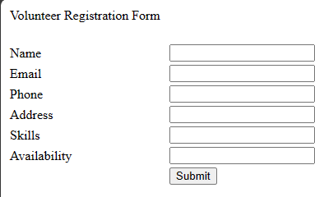

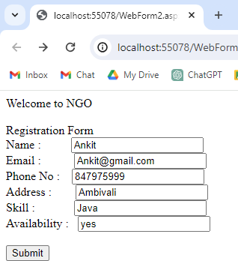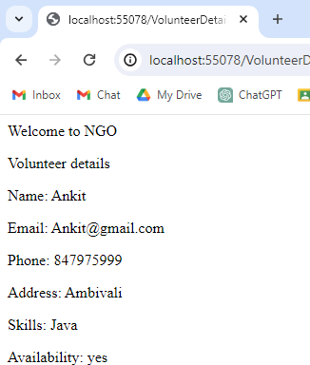

2.2. Create a simple website using ASP.NET Web Forms and the concept of a master page to accept student details and calculate/display the percentage of the student.

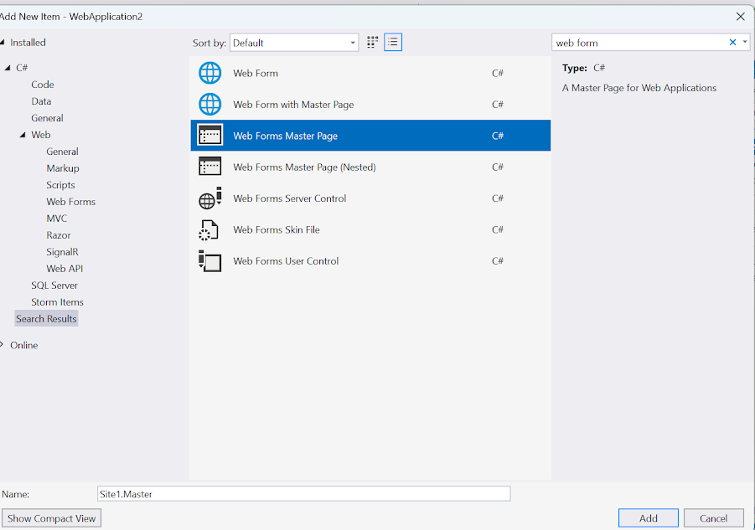

Code:

Webform 1

using System;

using System.Collections.Generic; using System.Linq;

using System.Web; using System.Web.UI;

using System.Web.UI.WebControls;

namespace Prac2B

{

public partial class WebForm1 : System.Web.UI.Page

{

protected void Page_Load(object sender, EventArgs e)

{

}

protected void Button1_Click(object sender, EventArgs e)

{

try

{

int marks1 = Convert.ToInt32(TextBox1.Text); int marks2 = Convert.ToInt32(TextBox2.Text);

double total = marks1 + marks2; double perc = (total * 100) / 200;

Label3.Text = "percentage:" + perc.ToString("0.00") + "%"; Label3.Visible = true;

}

catch

{

Label3.Text = "wrong data is entered";

}

}

}

}

Output:

